**Gavin Williamson visits Archie’s Attic. Friday 11th September 2020**

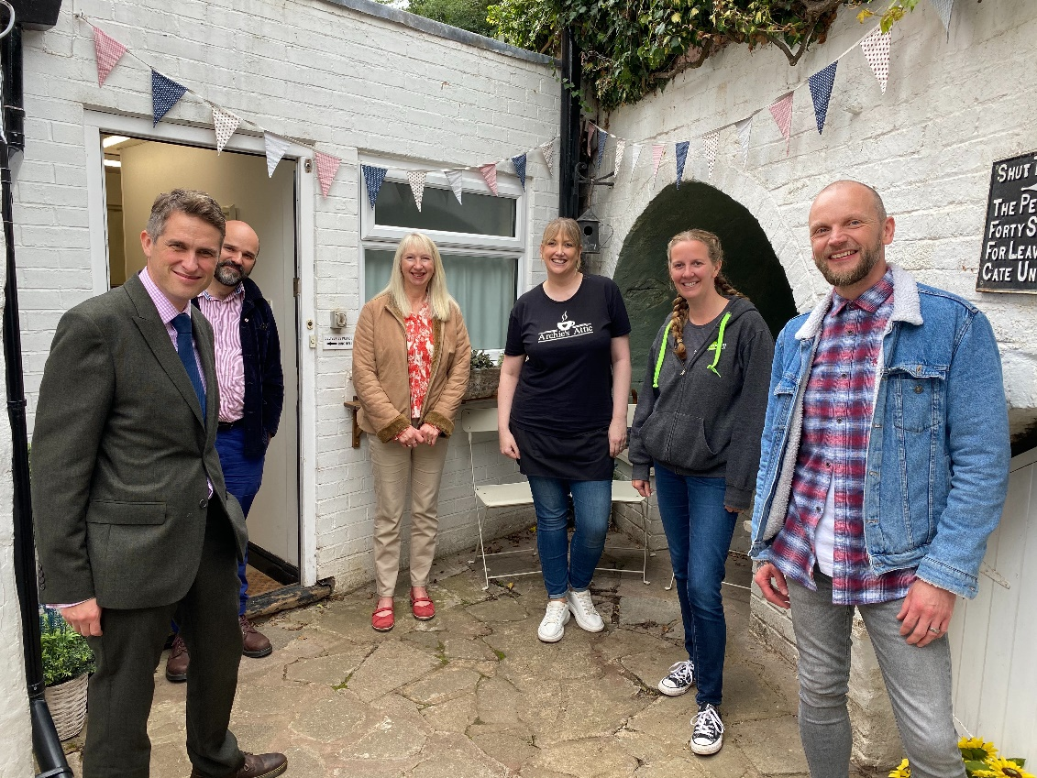

The Rt Hon Gavin Williamson MP visited Archie’s Attic Coffee shop in Enville to acknowledge & meet some of the team members, who during lockdown set up a support helpline for all Enville and Kinver residents to contact.

Unfortunately the business was one of the ones that had to temporarily close in March, but the owner Claire volunteered to become the call handler for the helpline and for just over 3 months, along with the help of the local shops, post office, pharmacy and 144 willing volunteers, were able to ensure both communities were supported and looked after during the crisis.

Archie’s Attic re-opened on 18th July and the coffee shop is not only a great place for Enville residents to meet up but is also welcoming new customers from outside of the village on a daily basis.

During lockdown whilst volunteering as the call handler for the helpline, Claire was fortunate to be nominated for an 02 Everyday Hero Award (which focuses on small businesses being affected by COVID-19) and was one of the five winners in the UK.

